Technicals

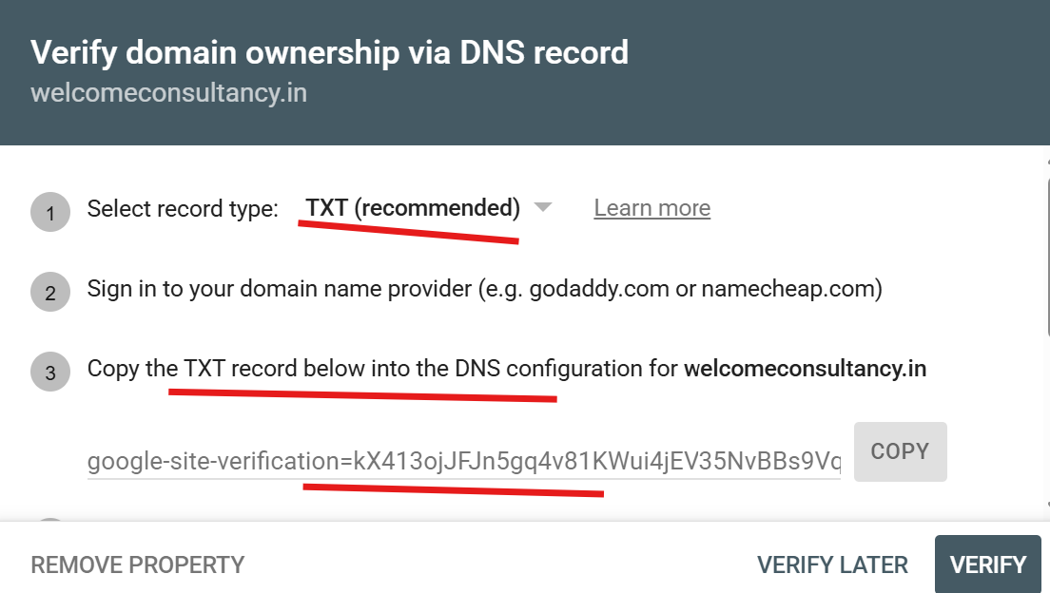

google-site-verification=kX413ojJFJn5gq4v81KWui4jEV35NvBBs9Vqj5xyn-Q

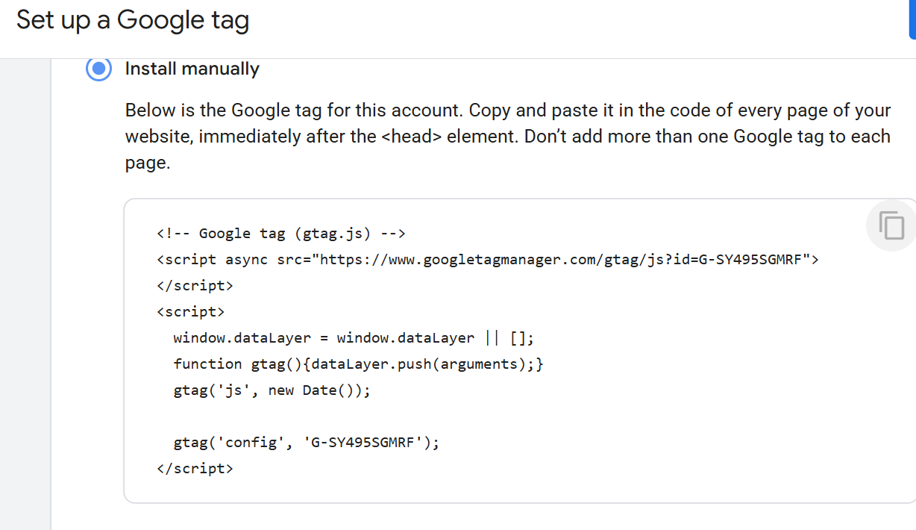

<!-- Google tag (gtag.js) -->
<script async src="https://www.googletagmanager.com/gtag/js?id=G-SY495SGMRF"></script>
<script>
window.dataLayer = window.dataLayer || [];
function gtag(){dataLayer.push(arguments);}
gtag('js', new Date());

gtag('config', 'G-SY495SGMRF');
</script>

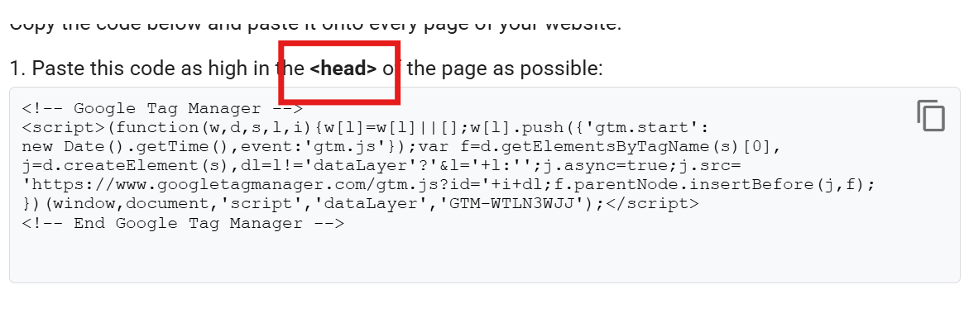
<!-- Google Tag Manager -->
<script>(function(w,d,s,l,i){w[l]=w[l]||[];w[l].push({'gtm.start':
new Date().getTime(),event:'gtm.js'});var f=d.getElementsByTagName(s)[0],
j=d.createElement(s),dl=l!='dataLayer'?'&l='+l:'';j.async=true;j.src=
'https://www.googletagmanager.com/gtm.js?id='+i+dl;f.parentNode.insertBefore(j,f);
})(window,document,'script','dataLayer','GTM-WTLN3WJJ');</script>
<!-- End Google Tag Manager -->

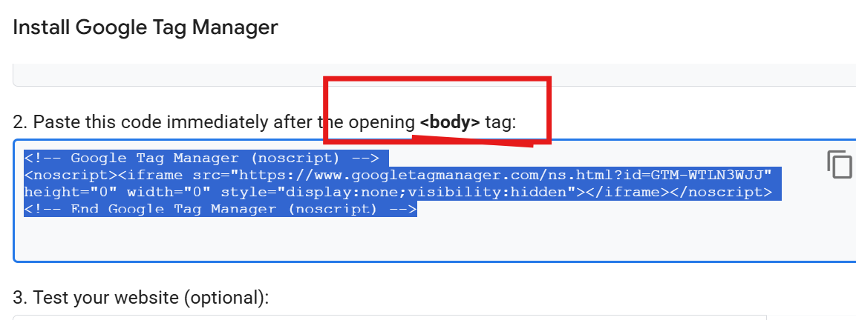

<!-- Google Tag Manager (noscript) -->
<noscript><iframe src="https://www.googletagmanager.com/ns.html?id=GTM-WTLN3WJJ"
height="0" width="0" style="display:none;visibility:hidden"></iframe></noscript>
<!-- End Google Tag Manager (noscript) -->

